1. **Create IAM Role**
2. **Attached 3 policies & attach IAM role to Instances.**

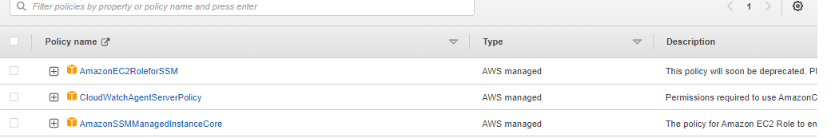

1. **Go to System Manager > Quick Setup > Create > Create**

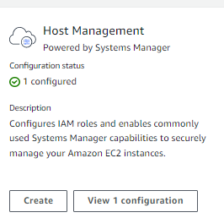

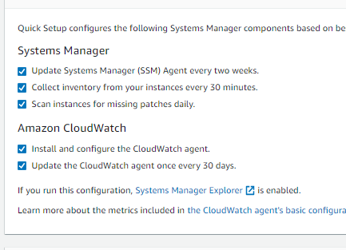

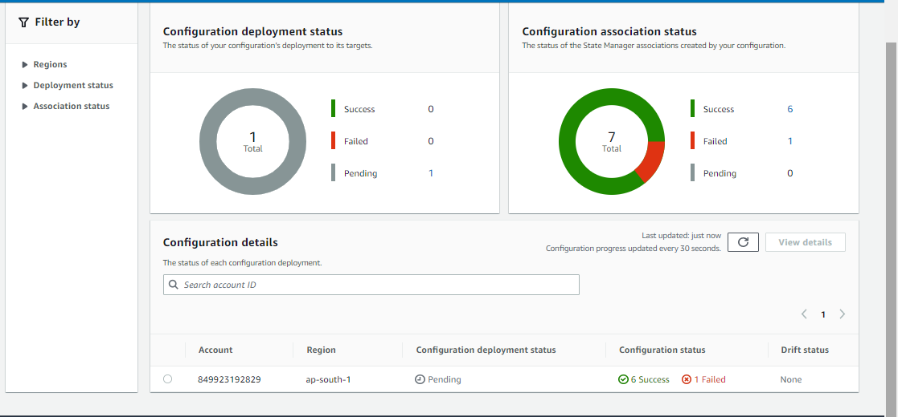

**Check in Cloudwatch >All Matrics**

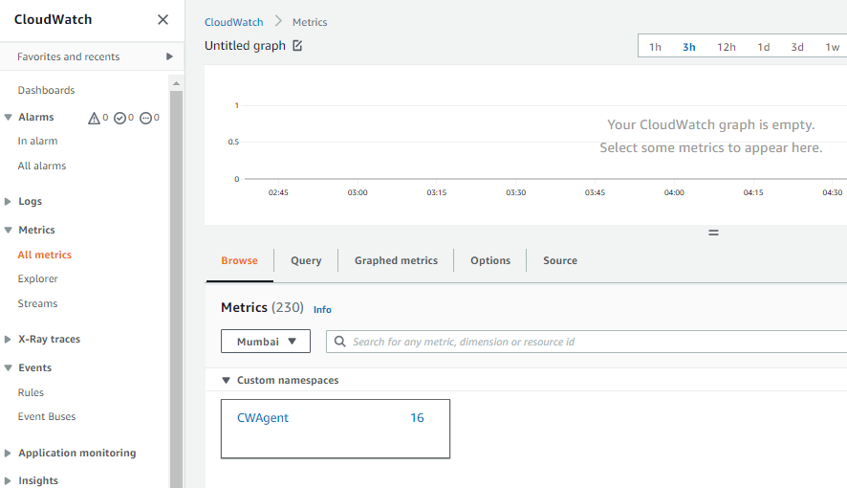

**SNS >Create topic >**

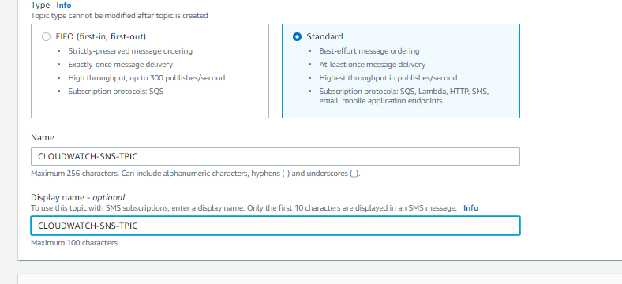

**Create Subscription**

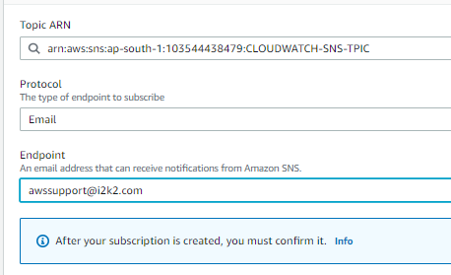

Go to give email and confirm subscription

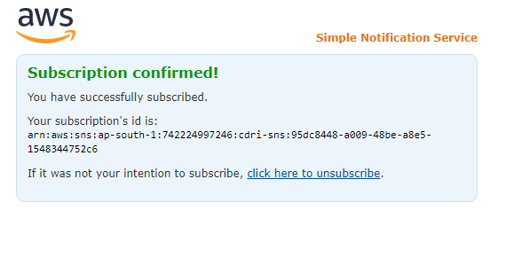

**//CREATE ALARM:**

Create Alarm > select metrics> statistic (Average)> Period(5min)>Threesold Type(Static)>Greater >80 >Next > select SNS topic>Next> Alarm Name>Next> Create Alarm

sudo apt-get install stress ///To increase CPU Utilization to check alarm

stress --cpu 2 --timeout 60